

School of Information Technology and Engineering

**Cloud Application Development**

**Final**

Title: **Cloud-Powered Event Management System**

Done by: **Altair Kabdrakhmanov**

**4th year student, ID: 21B030829,**

**Information Systems**

**Date of submission: 13th December**

Almaty, Fall 2024

# **Executive Summary**

This project is about a Cloud-Powered Event Management System with Google Cloud Platform (GCP). The system has features like user login, creating posts, and managing favorite categories. It uses tools like Firestore, Kubernetes, and Cloud Functions to work well and handle many users. The project also includes auto-scaling to manage traffic and Firebase for login. Pub/Sub is used for real-time notifications. In the future, adding Machine Learning with Vertex AI can make better post suggestions for users, and more features can be added to improve the system.

# **Table of Contents**

1. Introduction
2. System Architecture
3. Table Entities
4. Development Process
5. API Design and Implementation
6. Database Design and Optimization
7. Event-Driven Architecture
8. Machine Learning Integration
9. Security Measures
10. Scalability and Performance
11. Challenges and Solutions
12. Conclusion
13. References
14. Appendices

# **1. Introduction**

Google Cloud Platform (GCP) is a service that helps people build and run web applications in

the cloud. It is important for creating scalable applications because it has features like auto-

scaling, which means it can automatically adjust resources to handle more users or traffic. People

choose GCP for its cost-effectiveness since you only pay for what you use, and it allows for

faster development and deployment of applications. GCP also provides strong security to protect

data. Also, one of the motivation it was Free Trail 300$ that helped me to accomplish this work

# **2. System Architecture**

The system architecture of this project is based on Google Cloud Platform. It uses different cloud services like Firestore for storing data, Firebase for user authentication, and Kubernetes for managing the application. The system is designed as a Software as a Service (SaaS), where users can create accounts, make posts, and manage their favorite categories. Google Cloud Functions are used for security and input validation, and Pub/Sub is used for sending real-time notifications. The system is built to be scalable, meaning it can handle many users and large amounts of data without problems. Below the high-level overview of my application

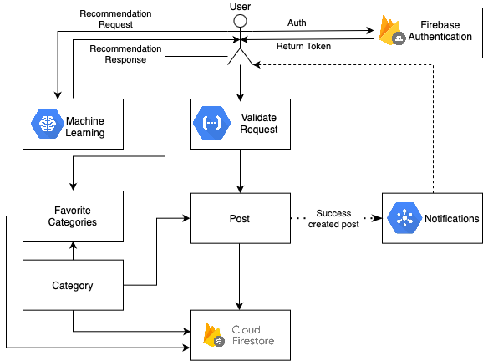

# **3. Table Entities**

1. User

Attributes:

* id: A unique identifier for each user (stored as user_id in Firestore).
* name: The name of the user.
* email: The email address of the user.
* password: The password of the user (hashed in Firebase).
* favoriteCategories: A list of categories that the user has marked as favorites.

Relationships:

* One-to-Many relationship with Post (a user can create multiple posts).
* One-to-Many relationship with favoriteCategories (a user can have multiple favorite categories).

2. Post

Attributes:

* id: A unique identifier for the post (UUID).
* tittle: The title of the post.
* text: The body or content of the post.
* category: The category associated with the post.
* userID: The ID of the user who created the post.
* createdTime: The timestamp when the post was created.

Relationships:

* Many-to-One relationship with User (a post belongs to a single user).
* Many-to-One relationship with Category (a post is associated with one category).

3. Category

Attributes:

* name: The name of the category.

Relationships:

* One-to-Many relationship with Post (a category can be associated with multiple posts).
* One-to-Many relationship with favoriteCategories (a category can appear in multiple users’ favorite categories).

# **4. Development Process**

## **Used technologies**

For this project I used Google Cloud SDK and Cloud Shell, Google App Engine, Google Cloud Functions, Containerization and Google Cloud Endpoints

## **Implementation:**

### Google Cloudk SDK

To start working on Google Cloud you need to download and install Google Cloud SDK. Do the followings to have Google Cloud SDK on your machine:

* Go to this page “Install the gcloud CLI” - <https://cloud.google.com/sdk/docs/install>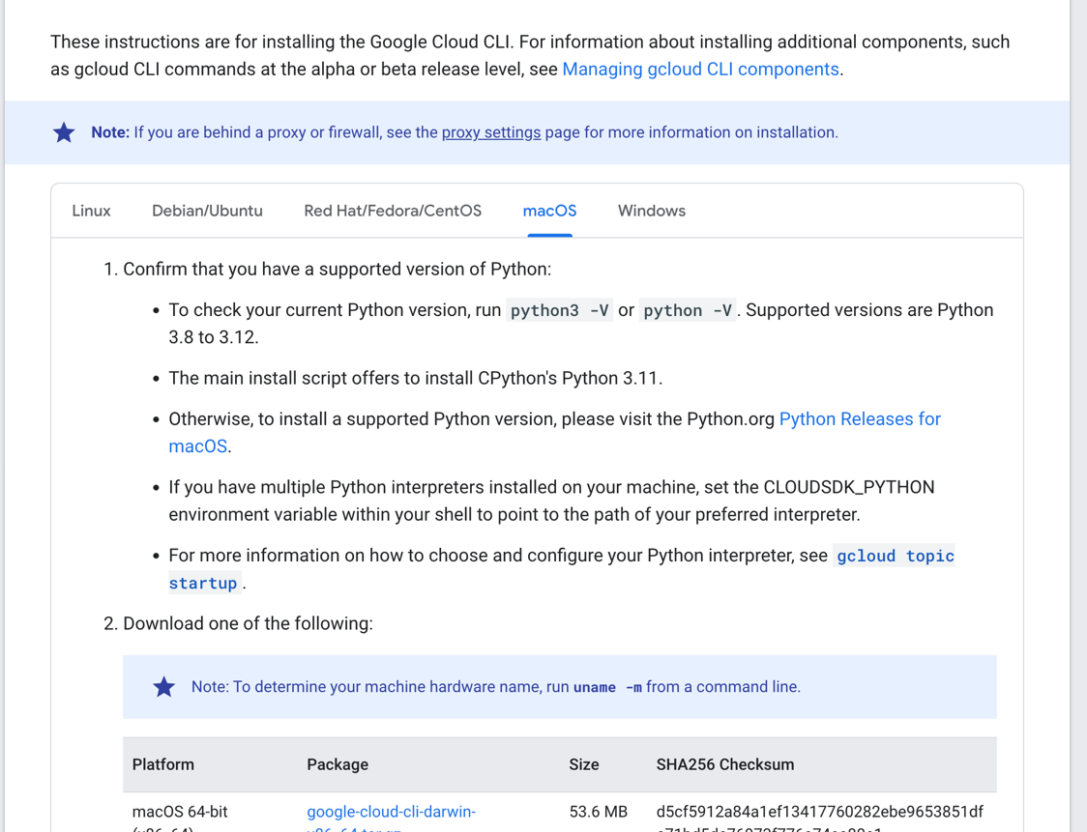
* Select your operating machine. For my case it is MacOS
* Check you current version of Python. It must match with requirements for Google Cloud SDK
* Download your package. For my case it is Apple Silicon
* Extract this archive file on Home directory.
* To add Google Cloud SDK to your PATH. You need to use this command in root of folder where you extracted the archive. For my case it is HOME directory. The command: ./google-cloud-sdk/install.sh
* Now you can run the gcloud auth login command and do authentication with your google cloud.

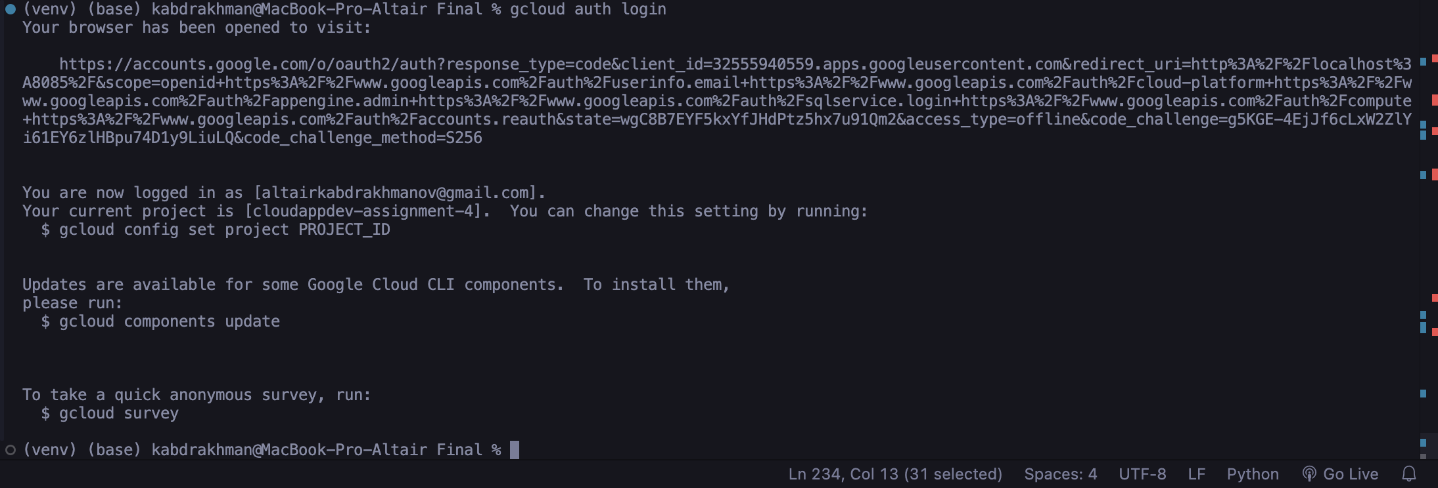

#### **Create Project**

Used this command to create my project: gcloud projects create --name="CloudAppDev-Final-AK"

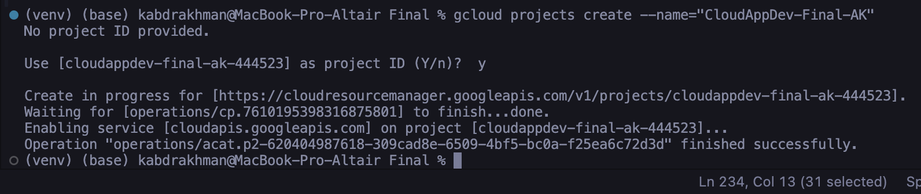

#### **Set Project**

Used this command to set as working project gcloud config set project cloudappdev-final-ak-444523

### Cloud Shell Usage

Also you can utilize Cloud Shell Usage that is already in Google Cloud Shell.

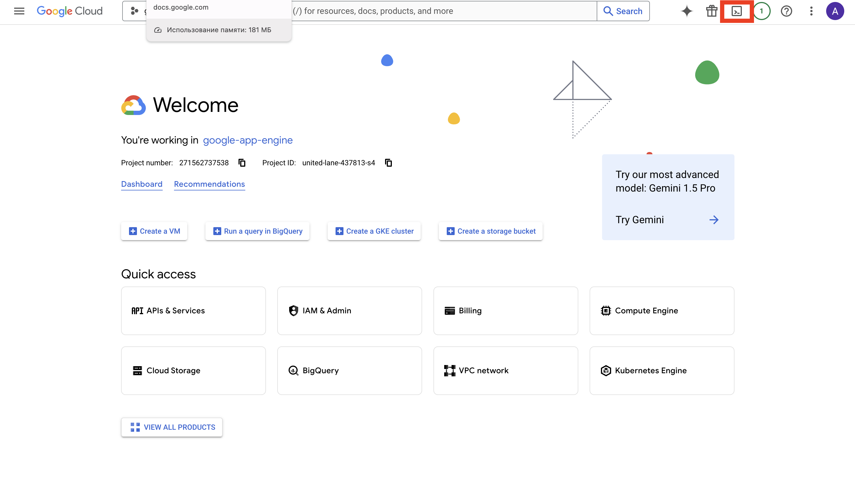

Click on this shell preview and you will obtain 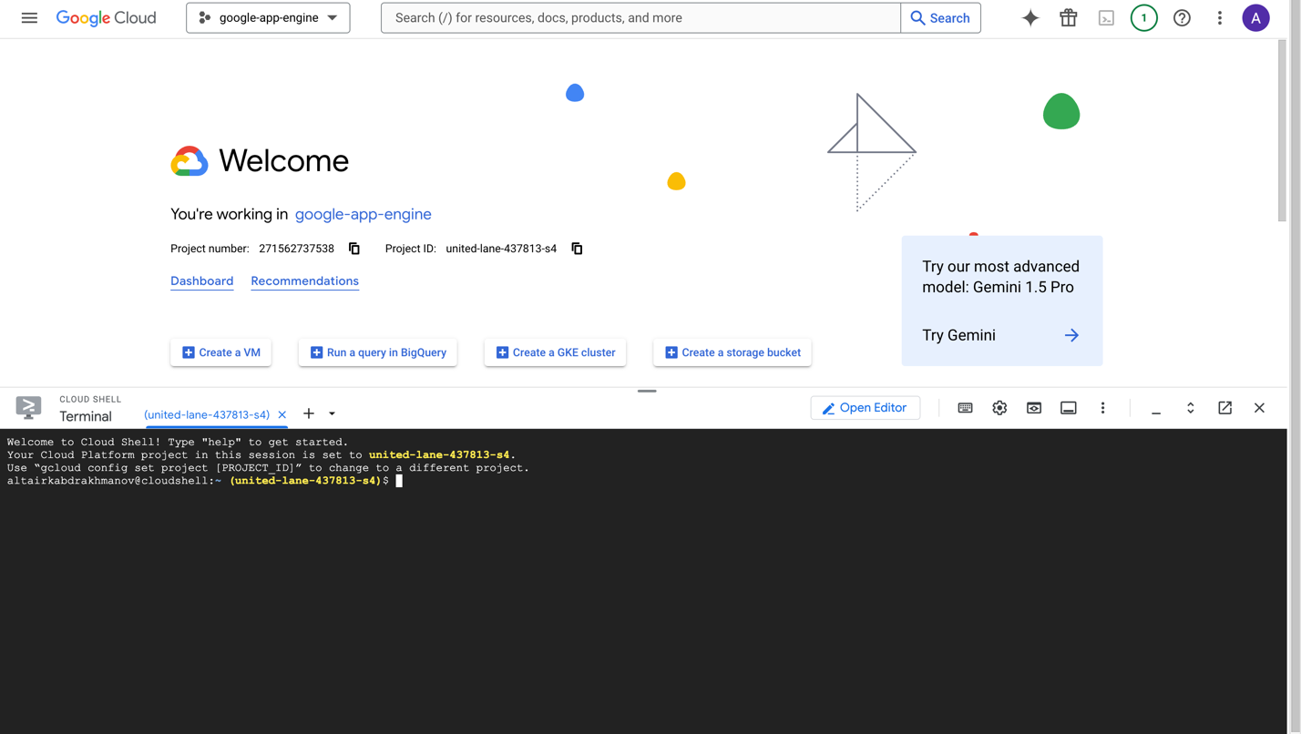

So it has the same functionality as Google Cloud SDK but it is within Google Cloud Console.

### Google App Engine

To deploy our application within Google Cloud Engine we need to create app.yaml file prior deploying. The app.yaml looks: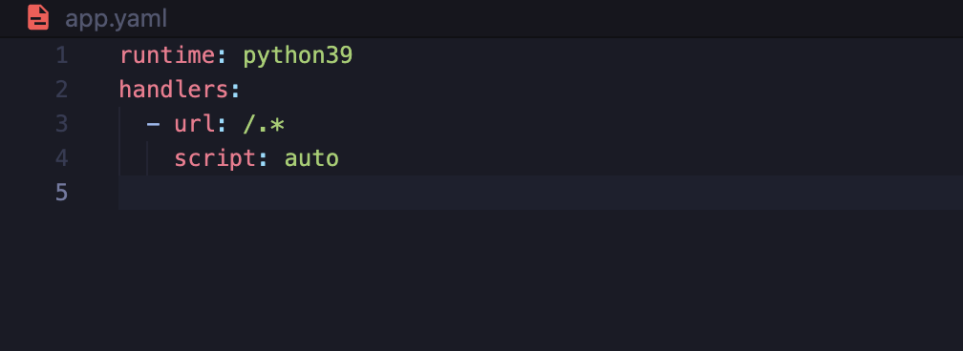

Used command to create requirements.txt: pip freeze > requirements.txt

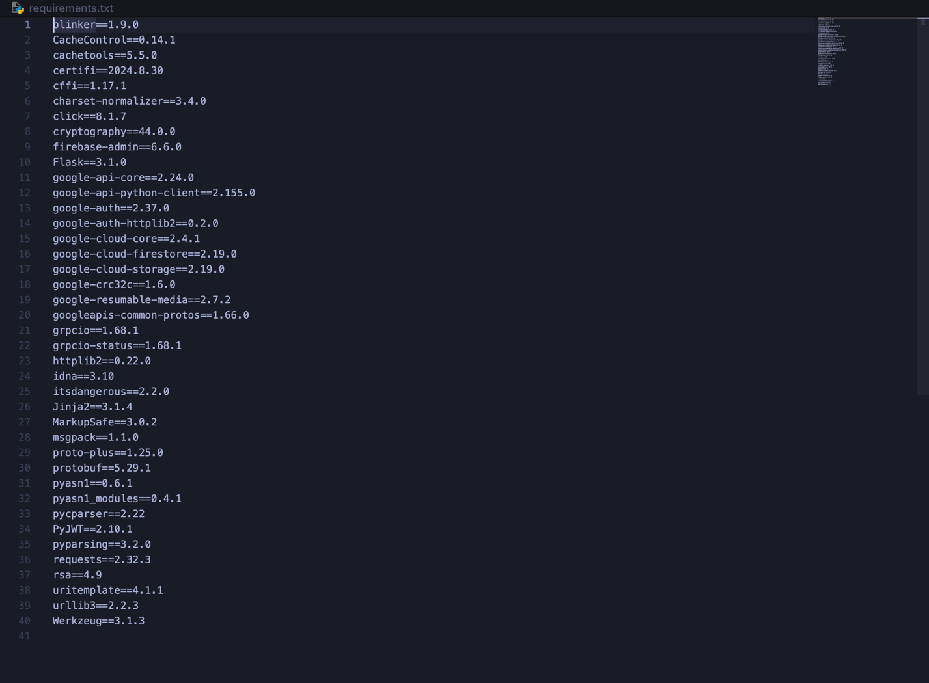

Used command to deploy: gcloud app deploy but before you need to activate billing account.

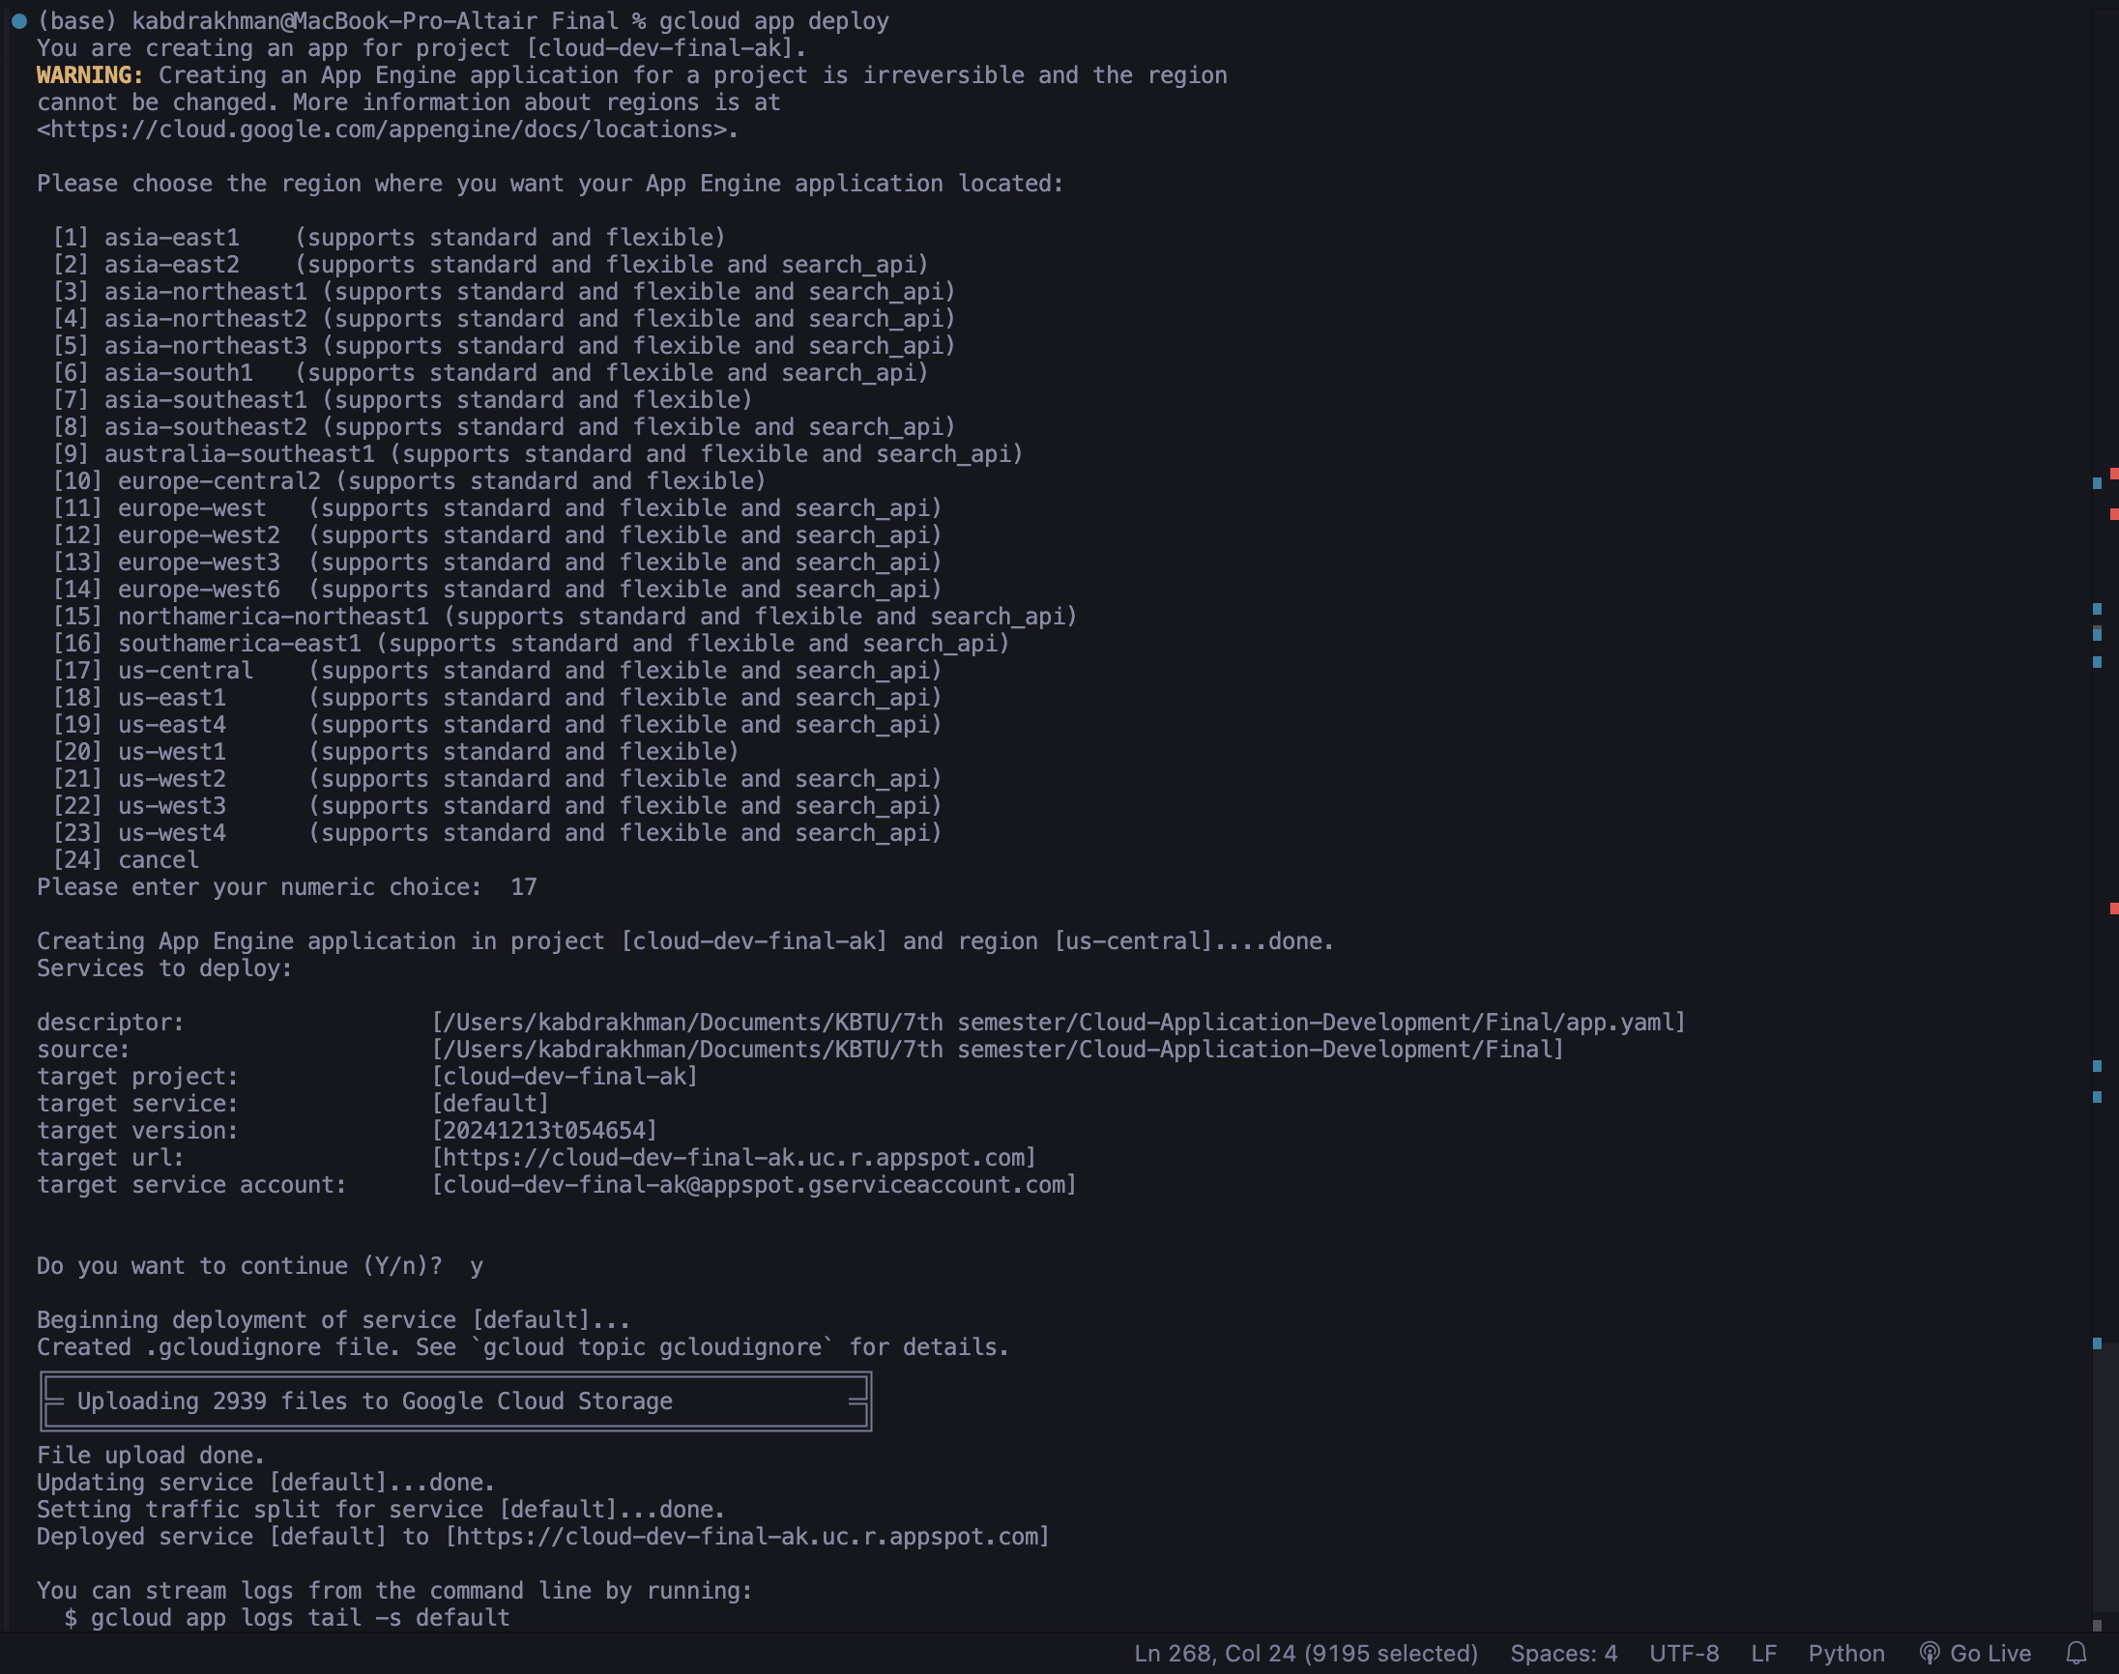

### Google Cloud Functions

Google Cloud Functions are used for input validation and logging.

To activate Google Cloud Function search function and click on “Create Function”.

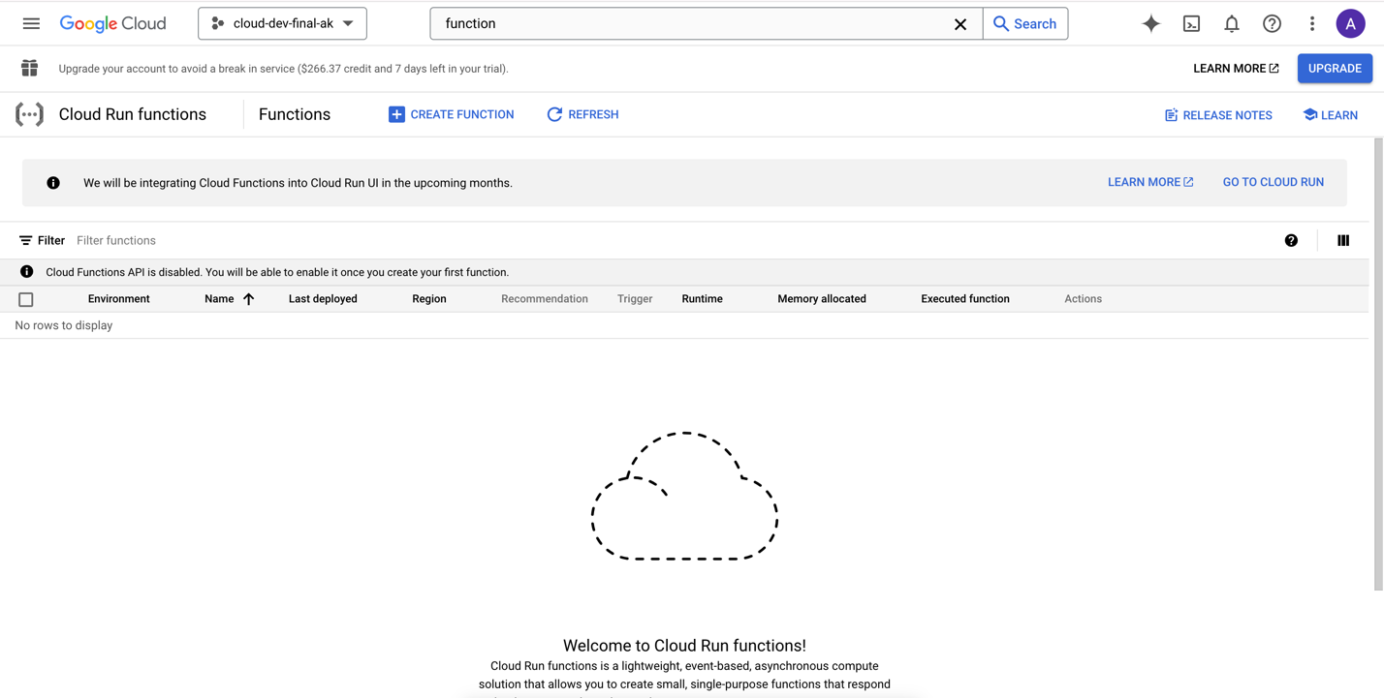

It will suggest to enable other dependencies of Cloud Function. Click on “ENABLE” and wait for activation completion.

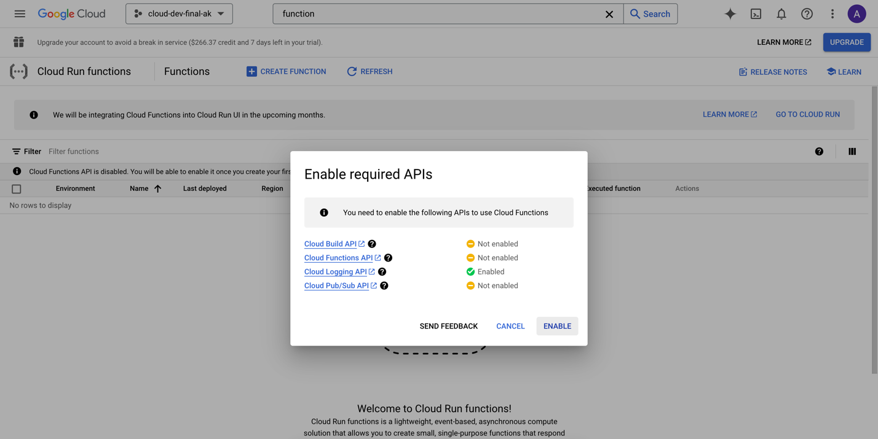

#### **Input Validation Cloud Function**

Code:  
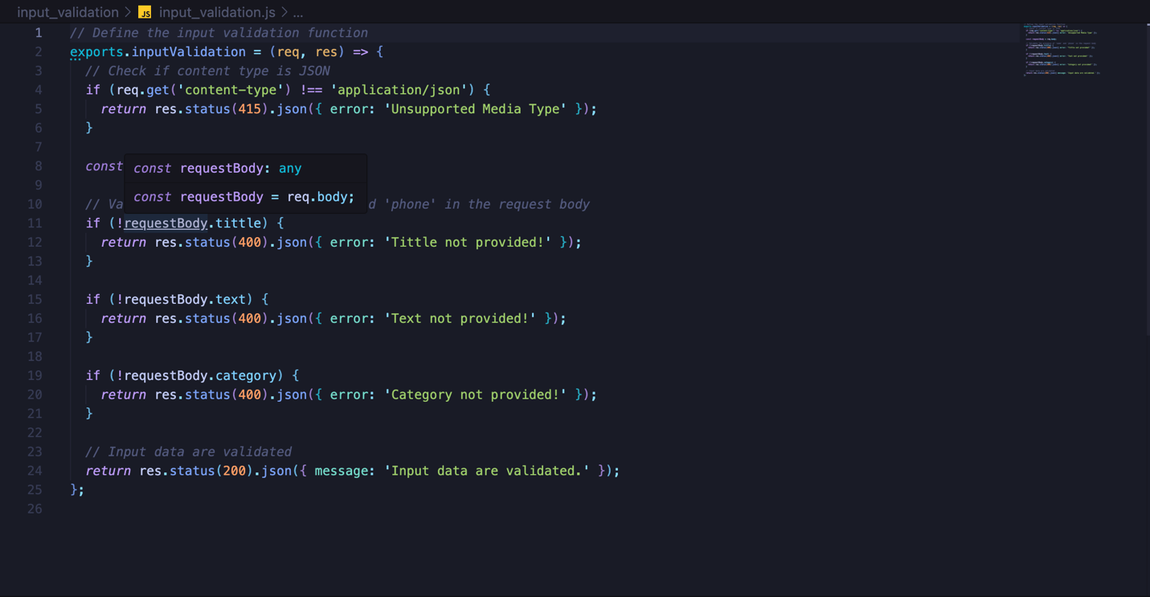

Command:

gcloud functions deploy inputValidation \

--runtime nodejs18 \

--trigger-http \

--allow-unauthenticated

Result:

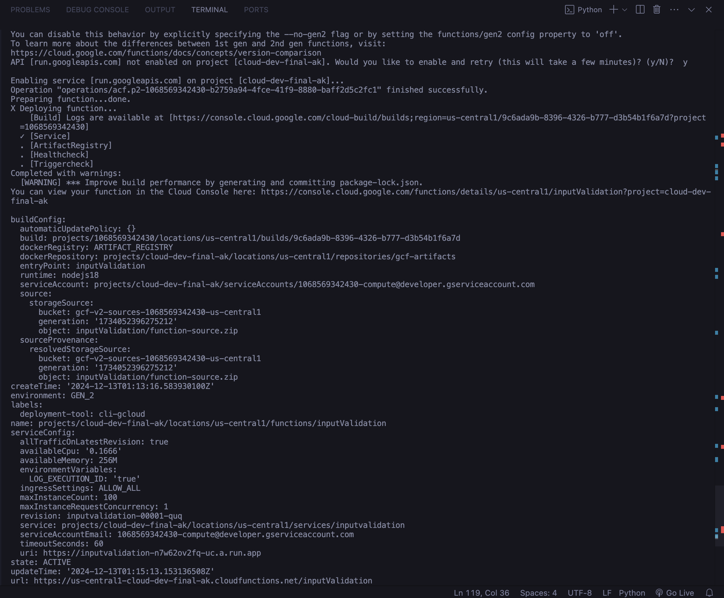

Integration with input_validation cloud function with users blog application:

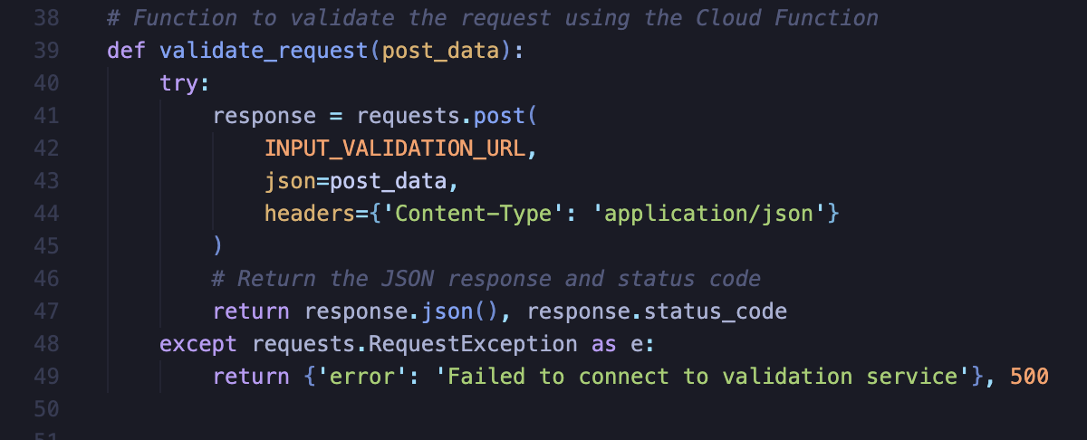

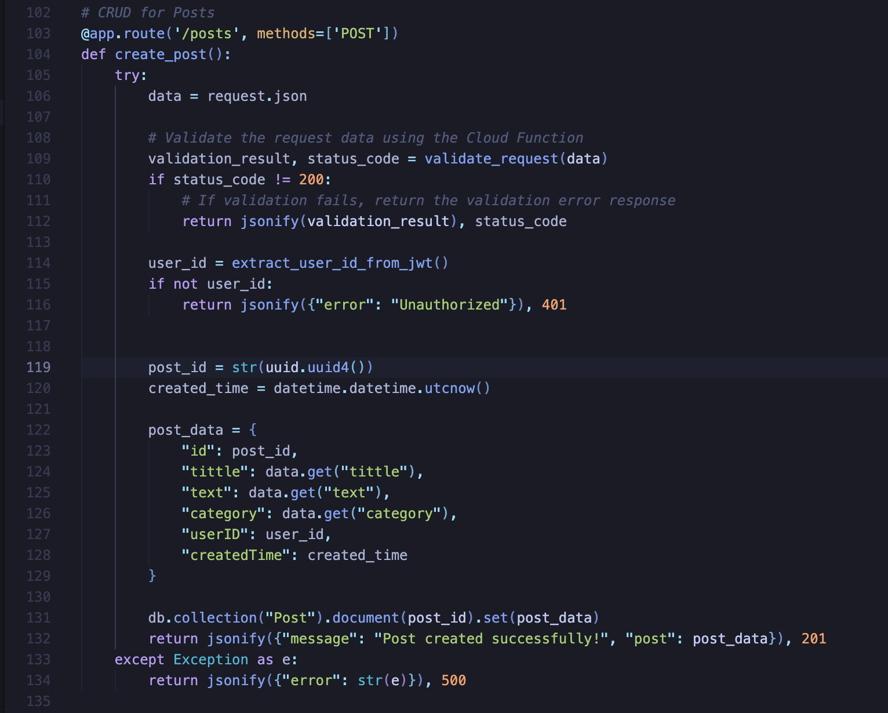

Result:

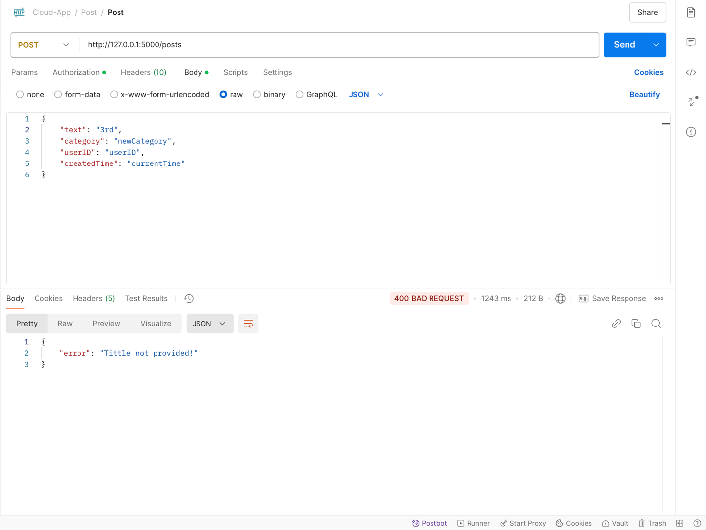

#### **Send notification cloud function**

Function post_notifcation for adding new Posts. The function itself:

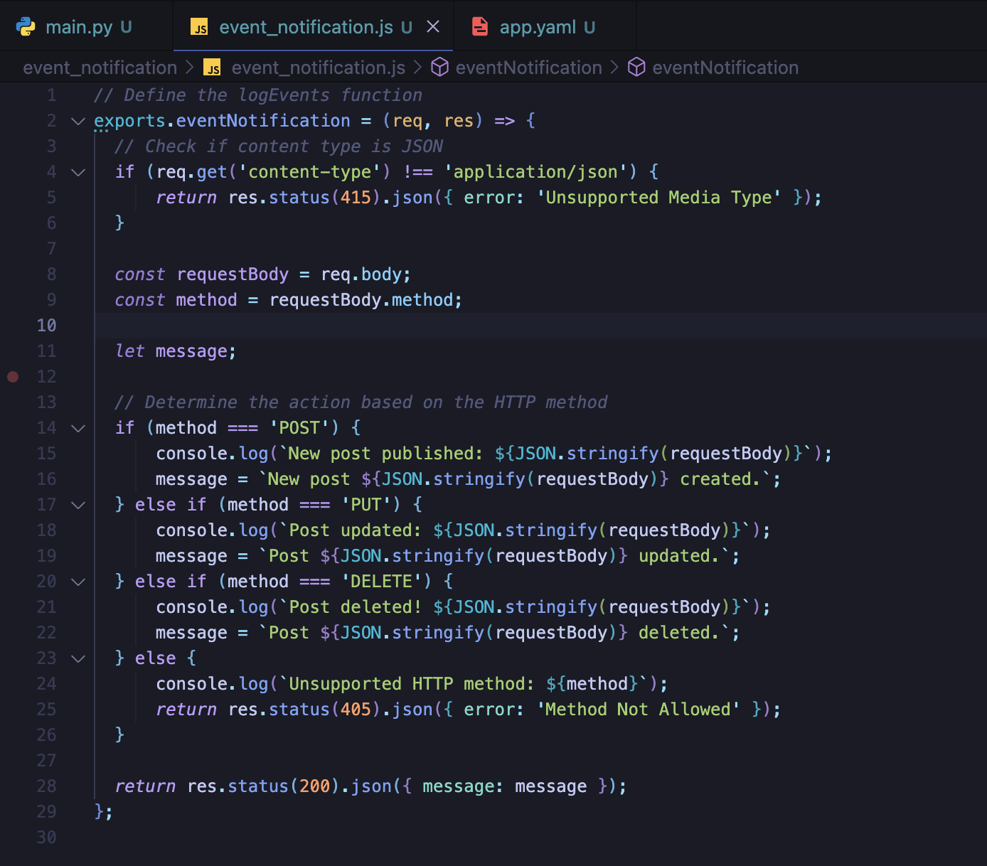

Command:

gcloud functions deploy eventNotification \

--runtime nodejs18 \

--trigger-http \

--allow-unauthenticated

Result:

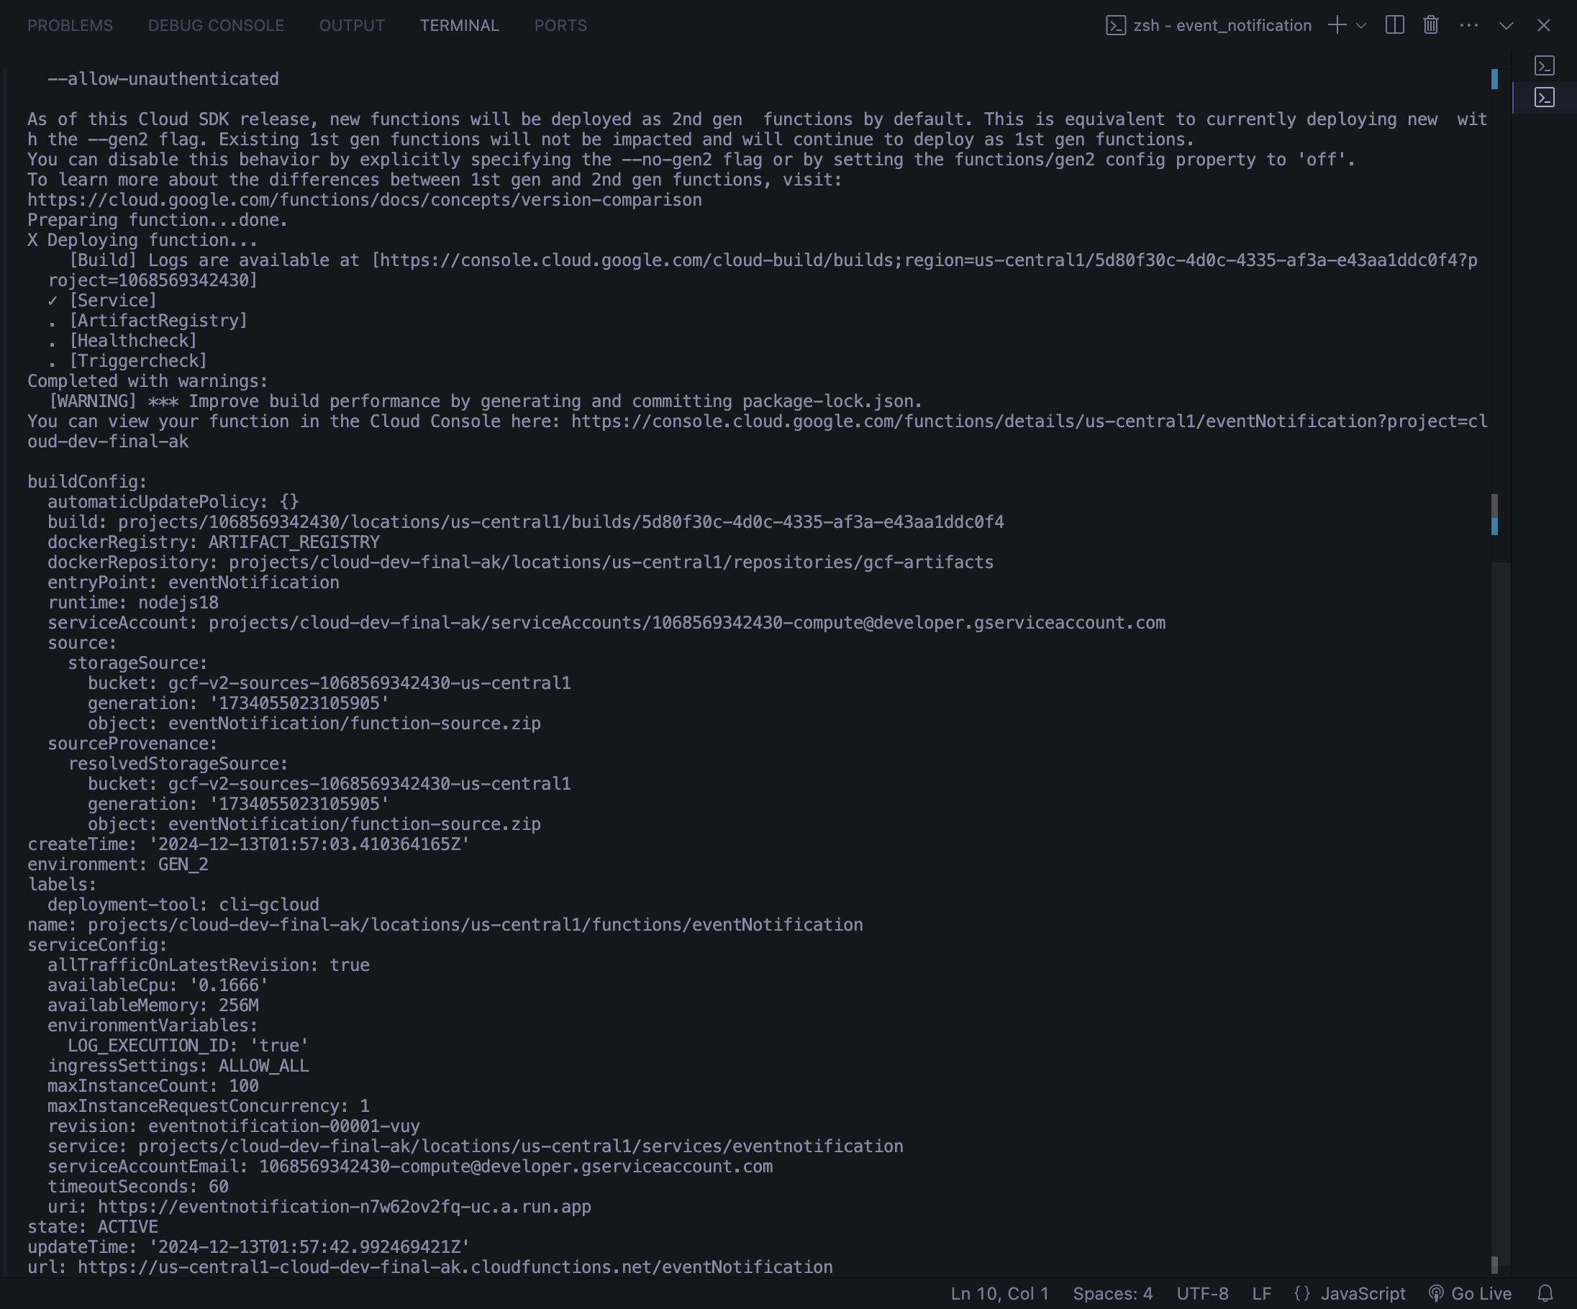

### Containerization

#### **Working with Dockerfile**

With step that need to be taken is to create Dockerfile for building image and further push to google cloud registry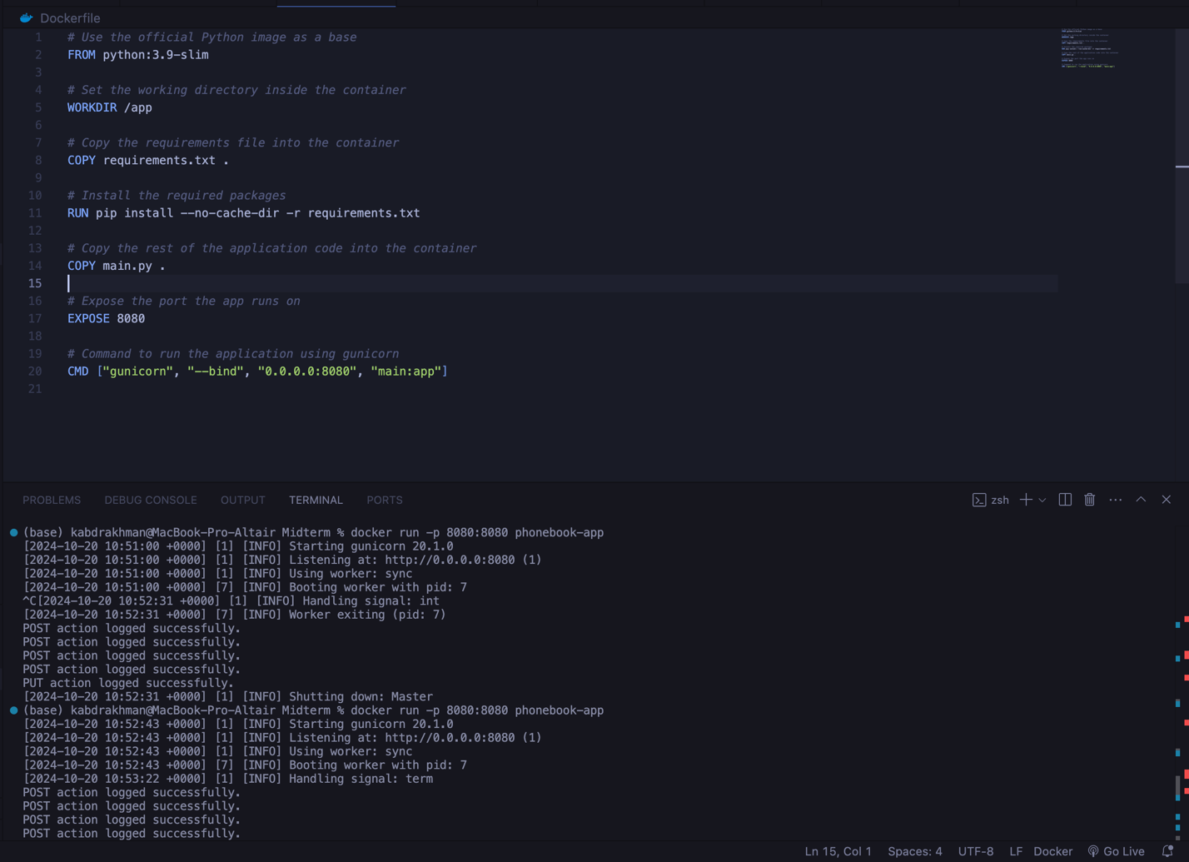

Command to build image with tag phonebook-app docker build -t users-blog .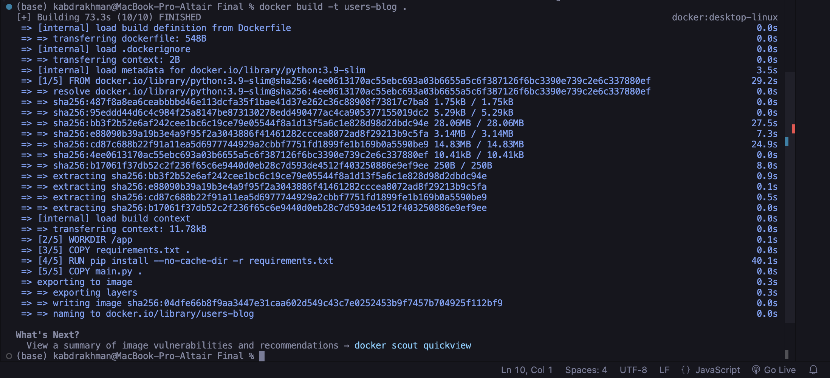

Prior pushing image to GCR, I tested locally with this command: docker run -p 8080:8080 users-blog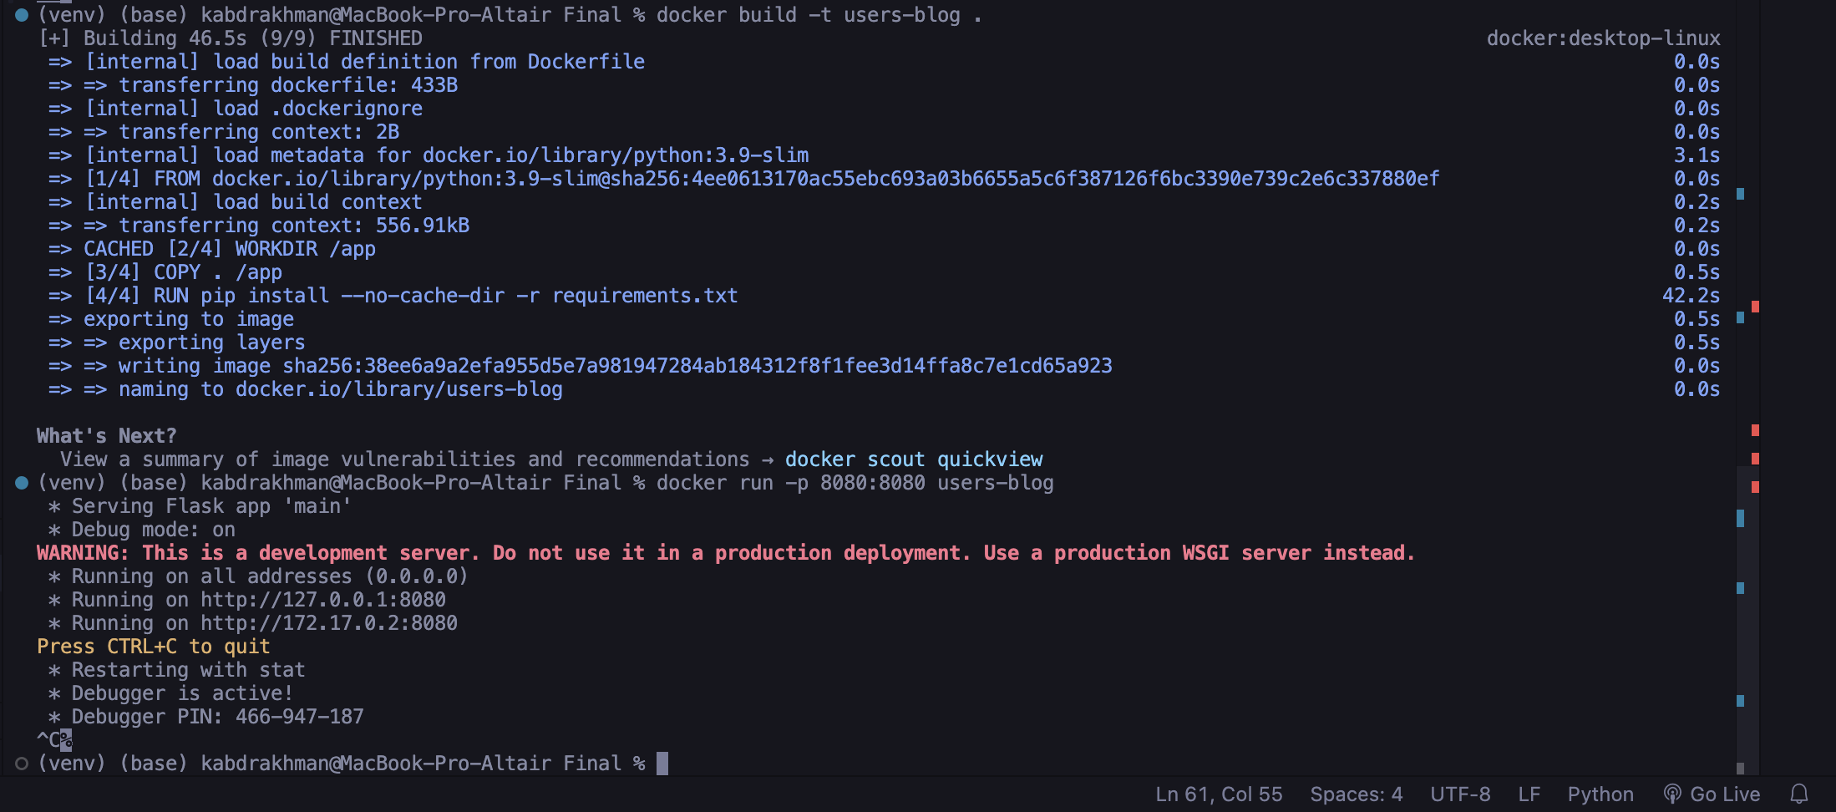

#### **Pushing image to GCR**

To have permission to add images into your remote docker registry on google cloud you need to execute this command:

gcloud auth configure-docker

To push my docker images I used this command to tag users-blog with my google cloud registry (GCR):

docker tag users-blog gcr.io/cloud-dev-final-ak/users-blog:latest

Only then I could push image to GCR

docker push gcr.io/cloud-dev-final-ak/users-blog:latest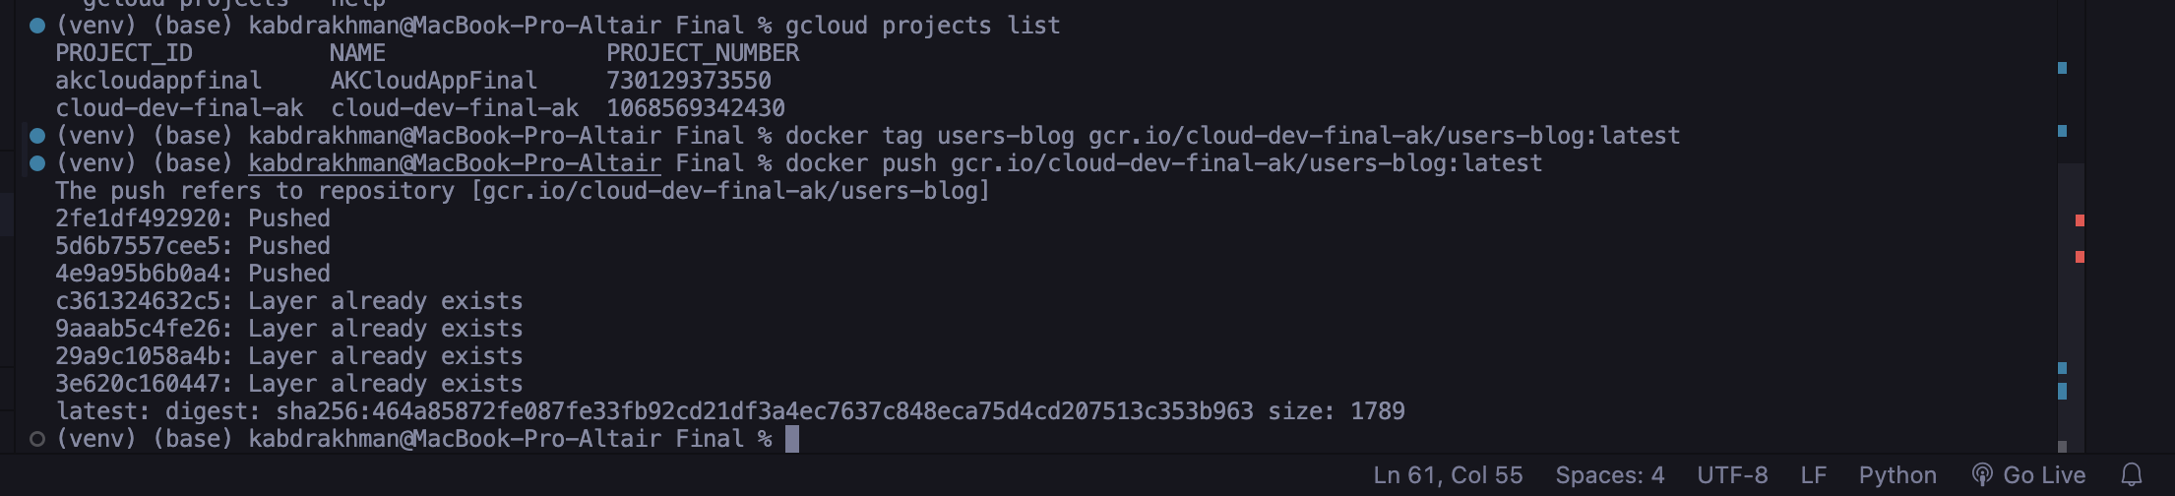

#### **Working with K8S**

To create kubernetes cluster used code:

gcloud container clusters create final-cluster \

--zone us-central1-a \

--num-nodes 1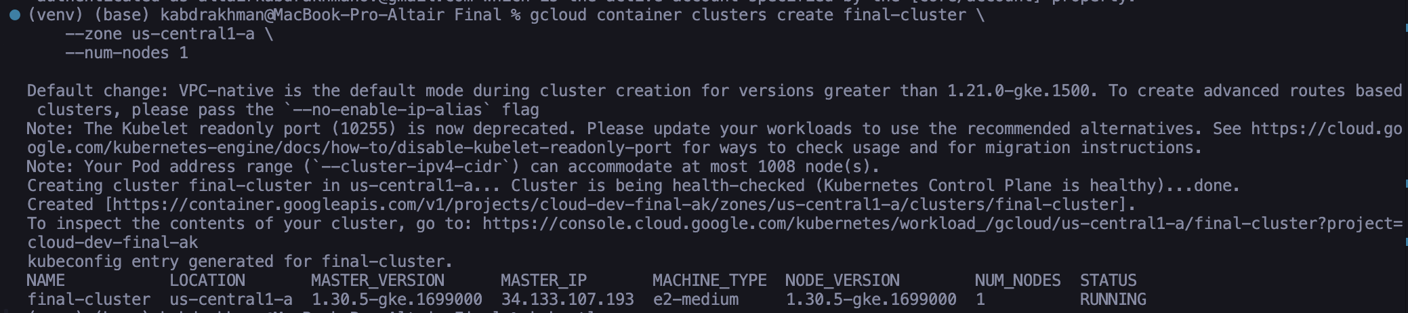

Result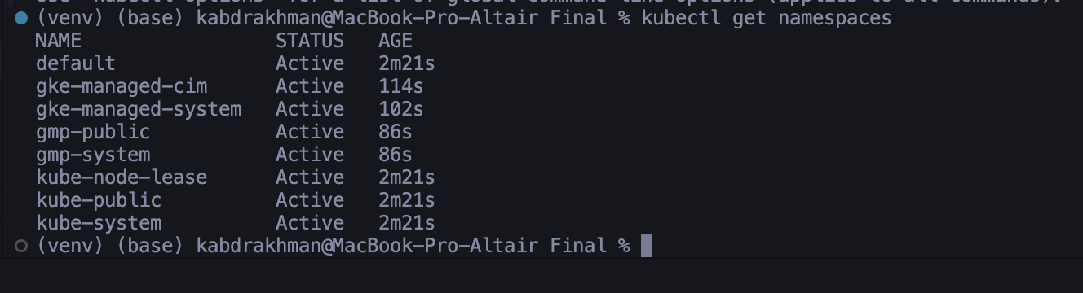

Create deployment and service yaml file with our application

Create separate namespace for our application

kubectl create namespace users-blog

### Google Cloud Endpoints

#### **API Setup**

To set up API using Cloud Endpoints we need to specify openAPI yaml file. Below you can find it. 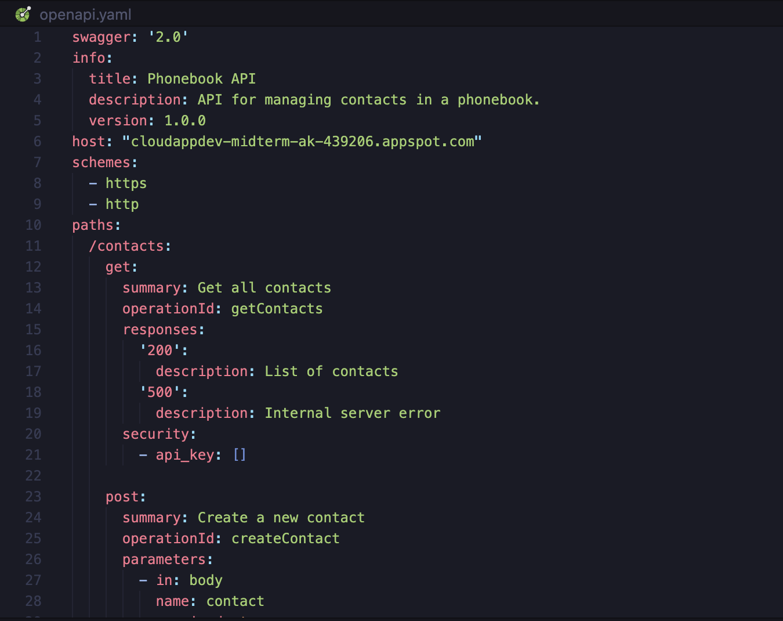

The host name must in this format: “project_id.appspot.com”, otherwise it doesn’t work. Below official documentation.

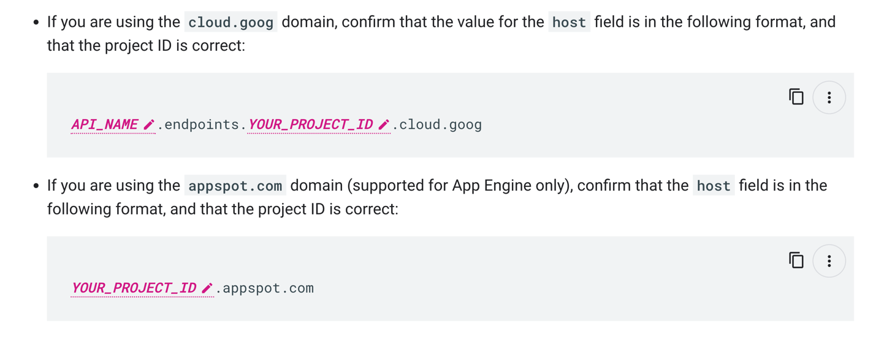

Command to deploy endpoint:

#### **API Deploy**

gcloud endpoints services deploy openapi.yaml

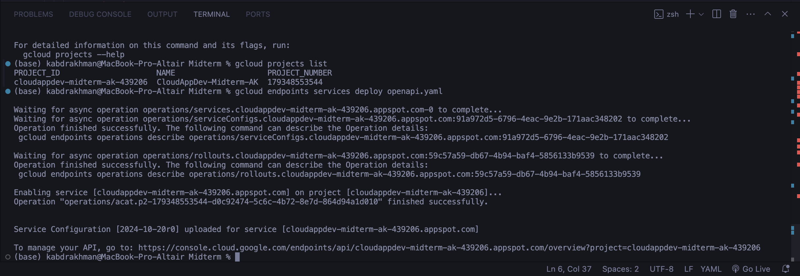

As result we can monitor now Post APIs by this link - https://console.cloud.google.com/endpoints/api/cloud-dev-final-ak.appspot.com/overview?project=cloud-dev-final-ak

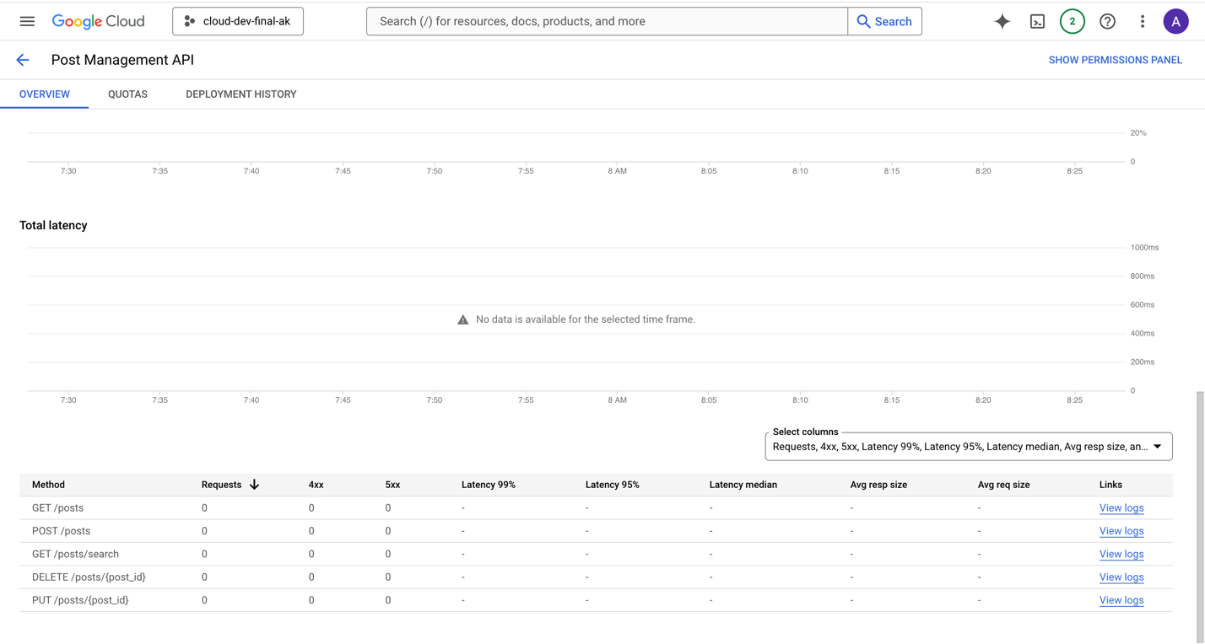

# **5. API Design and Implementation**

### User Authentication

1. Sign Up

* Method: POST
* Endpoint: /signup
* Description: Creates a new user account in Firebase Authentication and stores user details in Firestore.
* Request Body:

{

"email": "user@example.com",

"password": "password123",

"name": "John Doe"

}

* Responses:
  + Success (201):

{

"message": "User signed up successfully!",

"user_id": "unique_user_id"

}

* + Error (500): Error details.

1. Login

* Method: POST
* Endpoint: /login
* Description: Authenticates a user with Firebase and returns a JWT token.
* Request Body:

{

"email": "user@example.com",

"password": "password123"

}

* Responses:
  + Success (200):

{

"message": "Login successful!",

"token": "jwt_token"

}

* + Error (401 or 500): Error details.

### Post Management

1. Create Post

* Method: POST
* Endpoint: /posts
* Description: Creates a new post after validating the request via a Cloud Function.
* Request Body:

{

"tittle": "Post Title",

"text": "Post content",

"category": "Category Name"

}

* Responses:
  + Success (201):

{

"message": "Post created successfully!",

"post": { "id": "post_id", "tittle": "...", ... }

}

* Error: Validation errors or unauthorized access.

1. Get User Posts

* Method: GET
* Endpoint: /posts
* Description: Retrieves all posts created by the authenticated user.
* Response:
* Success (200):

{

"posts": [ { "id": "post_id", "tittle": "...", ... } ]

}

* Error: Unauthorized access.

1. Update Post

* Method: PUT
* Endpoint: /posts/<post_id>
* Description: Updates a specific post belonging to the authenticated user.
* Request Body: Fields to update.
* Responses:
  + Success (200):

{

"message": "Post updated successfully!",

"post": { "id": "post_id", "tittle": "...", ... }

}

* Error: Unauthorized access or post not found.

1. Delete Post

* Method: DELETE
* Endpoint: /posts/<post_id>
* Description: Deletes a specific post belonging to the authenticated user.
* Responses:
  + Success (200):

{

"message": "Post deleted successfully!"

}

* Error: Unauthorized access or post not found.

1. Search Posts

* Method: GET
* Endpoint: /posts/search
* Description: Searches posts based on a query string in the title or text.
* Query Parameters:
* query: The search term.
* Response:
* Success (200):

{

"posts": [ { "id": "post_id", "tittle": "...", ... } ]

}

### Favorite Categories Management

1. Manage Favorite Categories

* Method: GET, POST, PUT, DELETE
* Endpoint: /users/favoriteCategories
* Description: Manage a user’s favorite categories.
* Methods:
  + **GET**: Retrieve the list of favorite categories.
  + **POST**: Add a category to the favorites.
  + Request Body:

{ "category": "Category Name" }

* + **PUT**: Replace the entire list of favorite categories.
  + Request Body:

{ "categories": ["Category1", "Category2"] }

* + **DELETE**: Remove a category from the favorites.
  + Request Body:

{ "category": "Category Name" }

* + Responses:
    - Success (200): Relevant success messages.

1. Get Posts in Favorite Categories

* Method: GET
* Endpoint: /users/favoriteCategories/posts
* Description: Retrieves all posts in the user’s favorite categories.
* Response:
  + Success (200):

{

"posts": [ { "id": "post_id", "tittle": "...", ... } ]

}

Utilities

1. Input Validation

* URL: INPUT_VALIDATION_URL
* Description: A Cloud Function URL used to validate post creation requests.

1. Event Logging

* URL: EVENT_NOTIFICATION_URL
* Description: A Cloud Function URL used to log events.

# **6. Database Design and Optimization**

I chose Firestore because it is a flexible, scalable, and easy to use database. It is a cloud-based NoSQL database, which means it stores data in documents and collections, making it simple to organize and access. It also easy to integrate with Firebase Authentication, making it easy to connect users to posts, categories, data and etc.

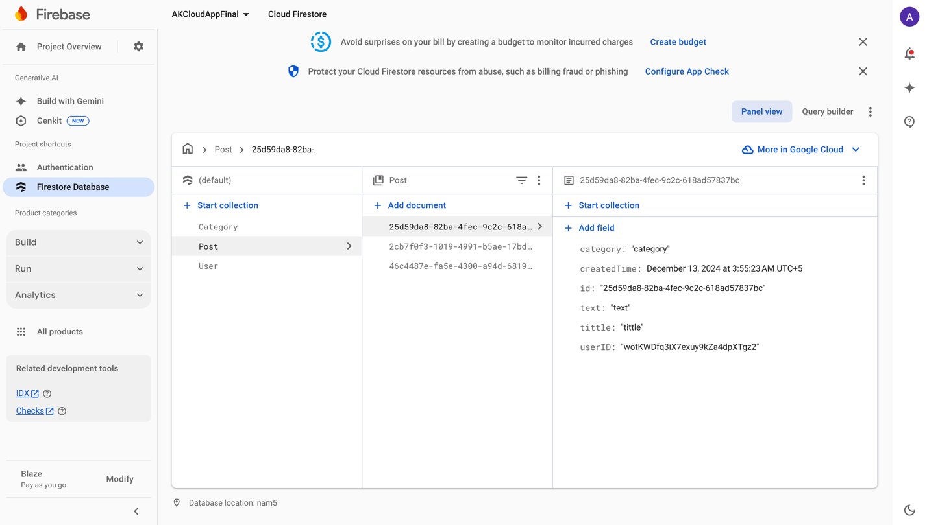

# **7. Event-Driven Architecture**

For Event-Driven Architecture Google has its own technology – Google Cloud Pub/Sub. Do the following.

First, we need to create topic in Pub/Sub

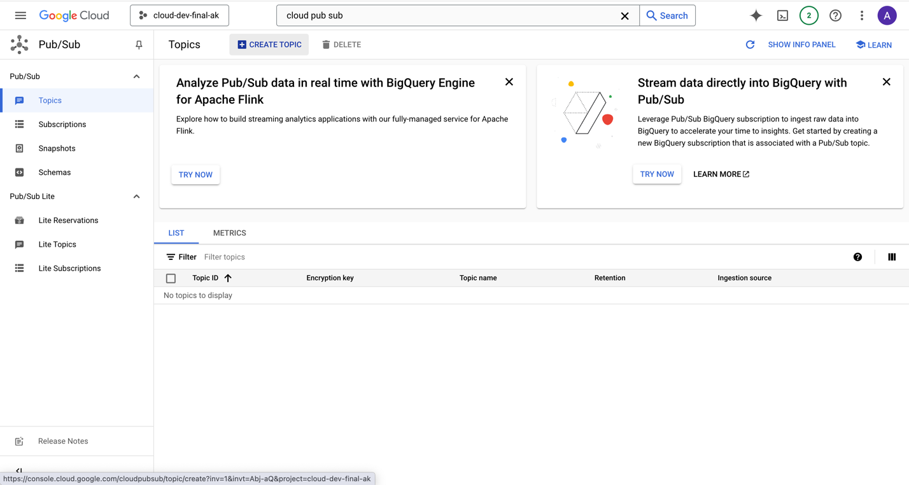

Created post-events topic

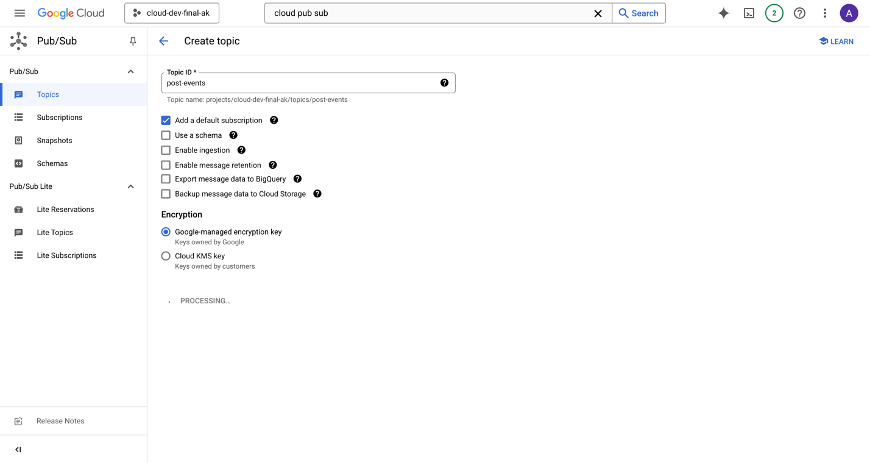

Log event with pub/sub

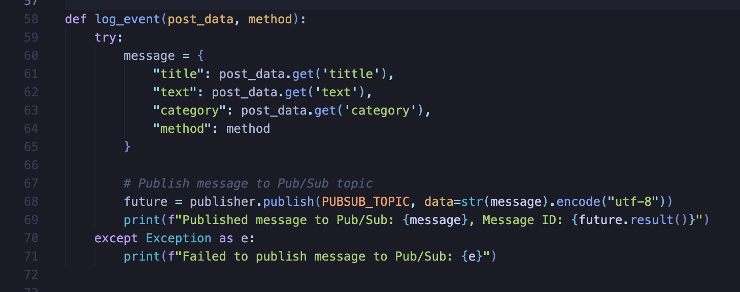

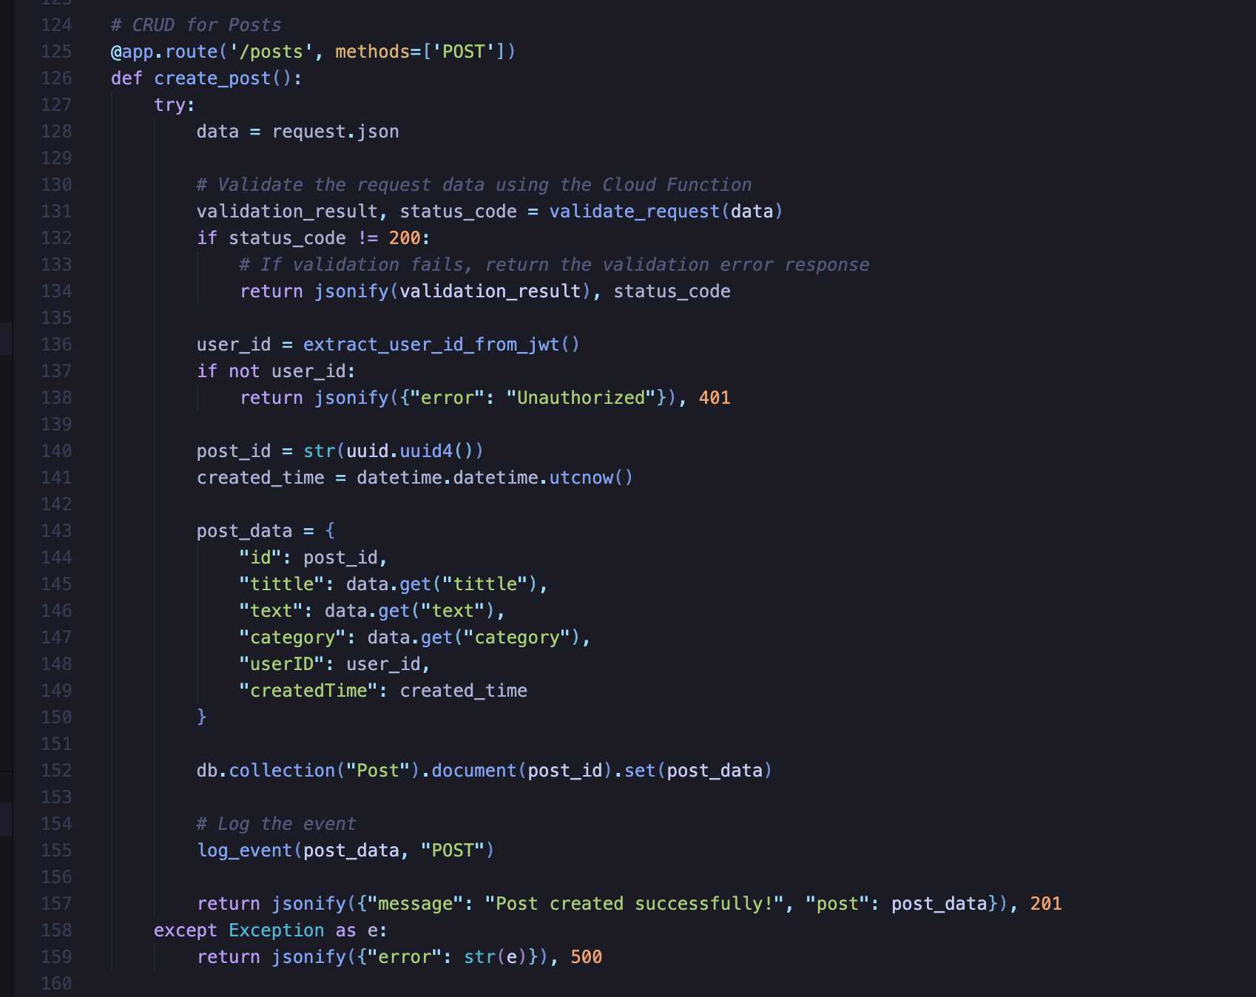

**The result:** 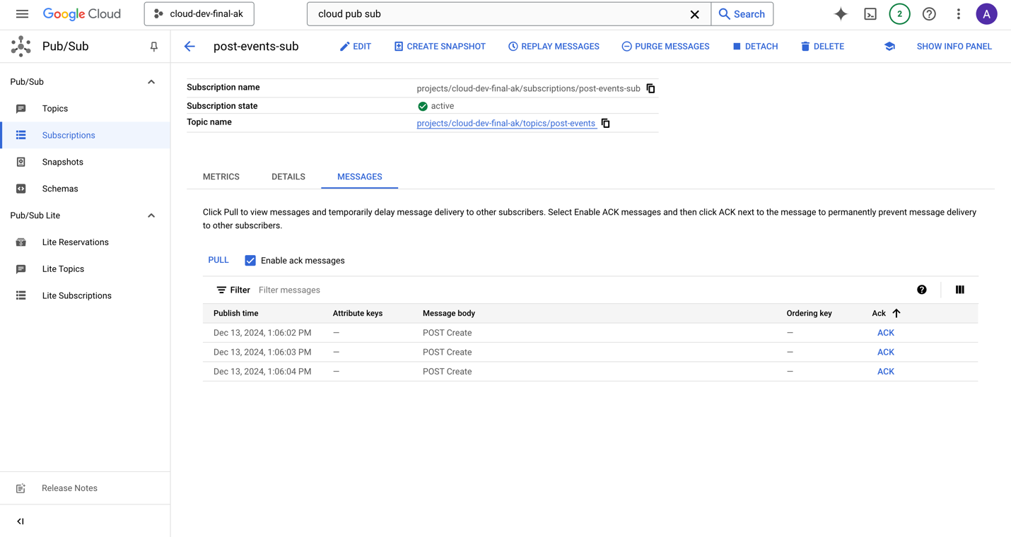

# **8. Machine Learning Integration**

There is a favorite categories for users. Using this, we could recommend posts that match the user’s interests. Right now, it is based on simple filters (like matching the category), but with machine learning, we could improve this by analyzing user behavior and suggesting posts they are more likely to enjoy.

For this purpose we can use Vertex AI that can take favorite categories and find similar to person category and suggest that as next posts.

# **9. Security Measures**

Authentication and authorization is based on Firebase Authentication that securely provide JWT token based on that user-blog application decide to provide or not the necessary resourcers.

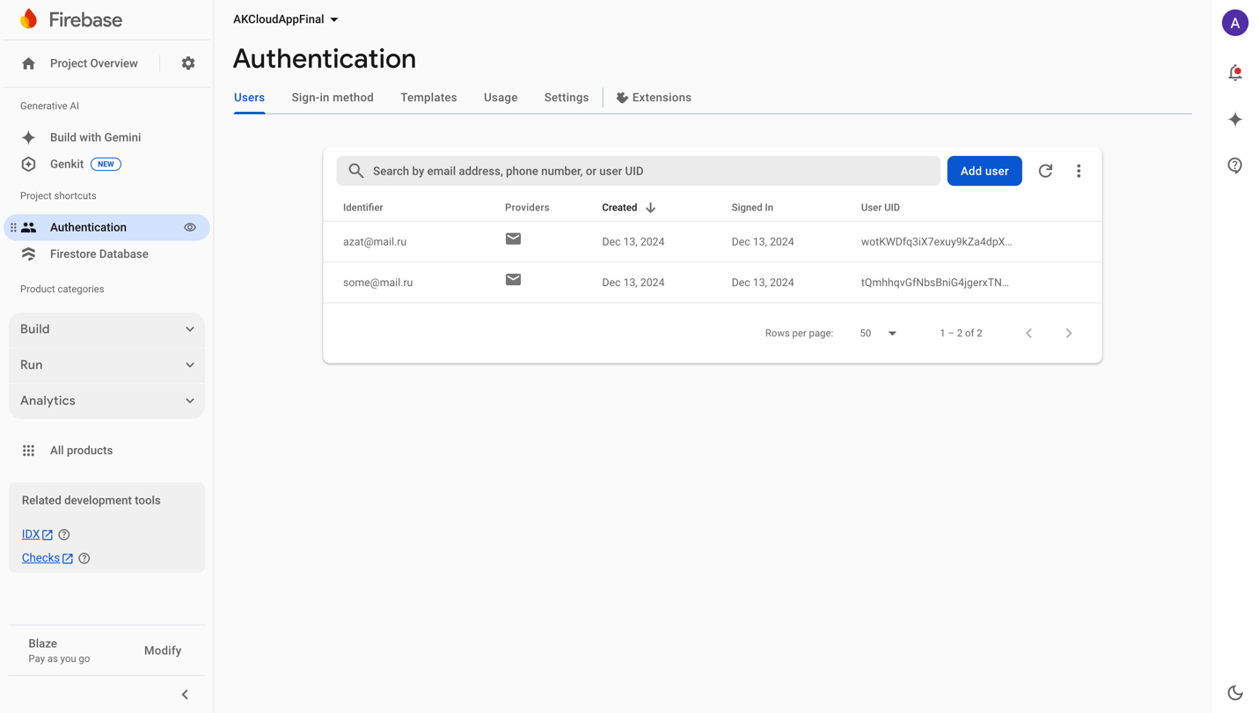

Data validation is implemented on level of Cloud functions -

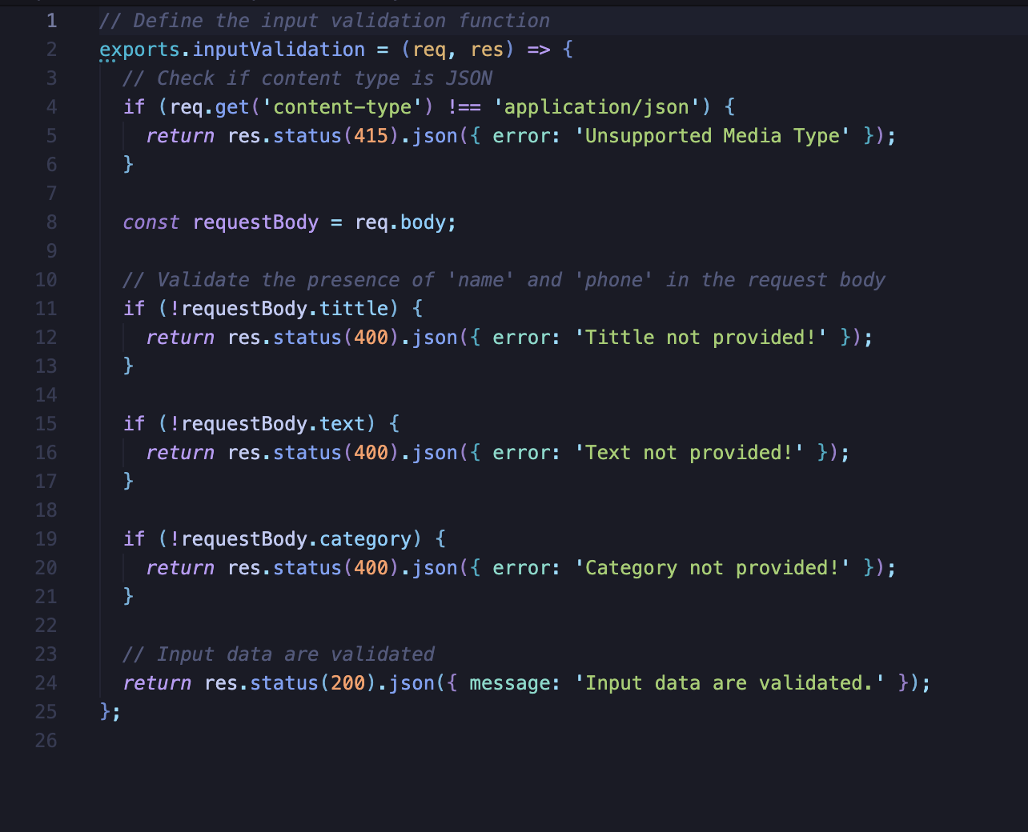

# **10. Scalability and Performance**

## **Scalability**

It is the ability of a system to handle more work or support more users when needed. It is important because it helps applications run smoothly even when there are more requests or higher demand.

There are two main types of autoscaling:

1. Horizontal Autoscalling means adding more machines or instances to share the workload.It is good for applications that do not keep data on the instance (stateless), so any instance can handle any request. Benefits: Better performance, higher availability, and less chance of failure.
2. Vertical Autoscalling means increasing the power of one machine, like adding more CPU or memory. It works well for applications that keep important data in the instance (stateful). Benefits: Simpler to set up, but there is a limit to how much you can upgrade one machine.

Both methods can be used together depending on the needs of the application. In cloud systems like Google Cloud, tools like auto-scaling can make scaling automatic, saving both time and effort.

### Horizonatl autoscalling

To enable **horizonatl autoscalling** it was defined HorizontalPodAutoscaler that will increase the number of instances if cpu usage exceeds more than 50 percents.

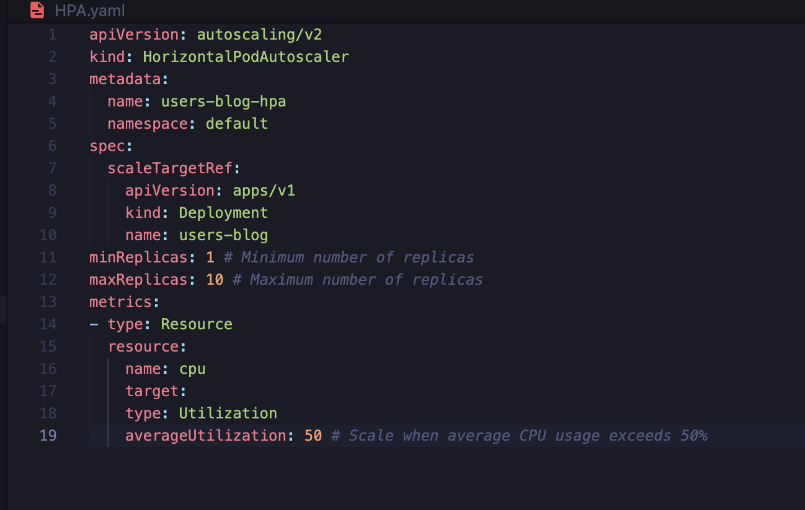

### Vertical autoscaling

For **vertical autoscaling** it was added limits field to enable scaling memory and CPUs for my instance.It means it will use more than requested cpu and memory 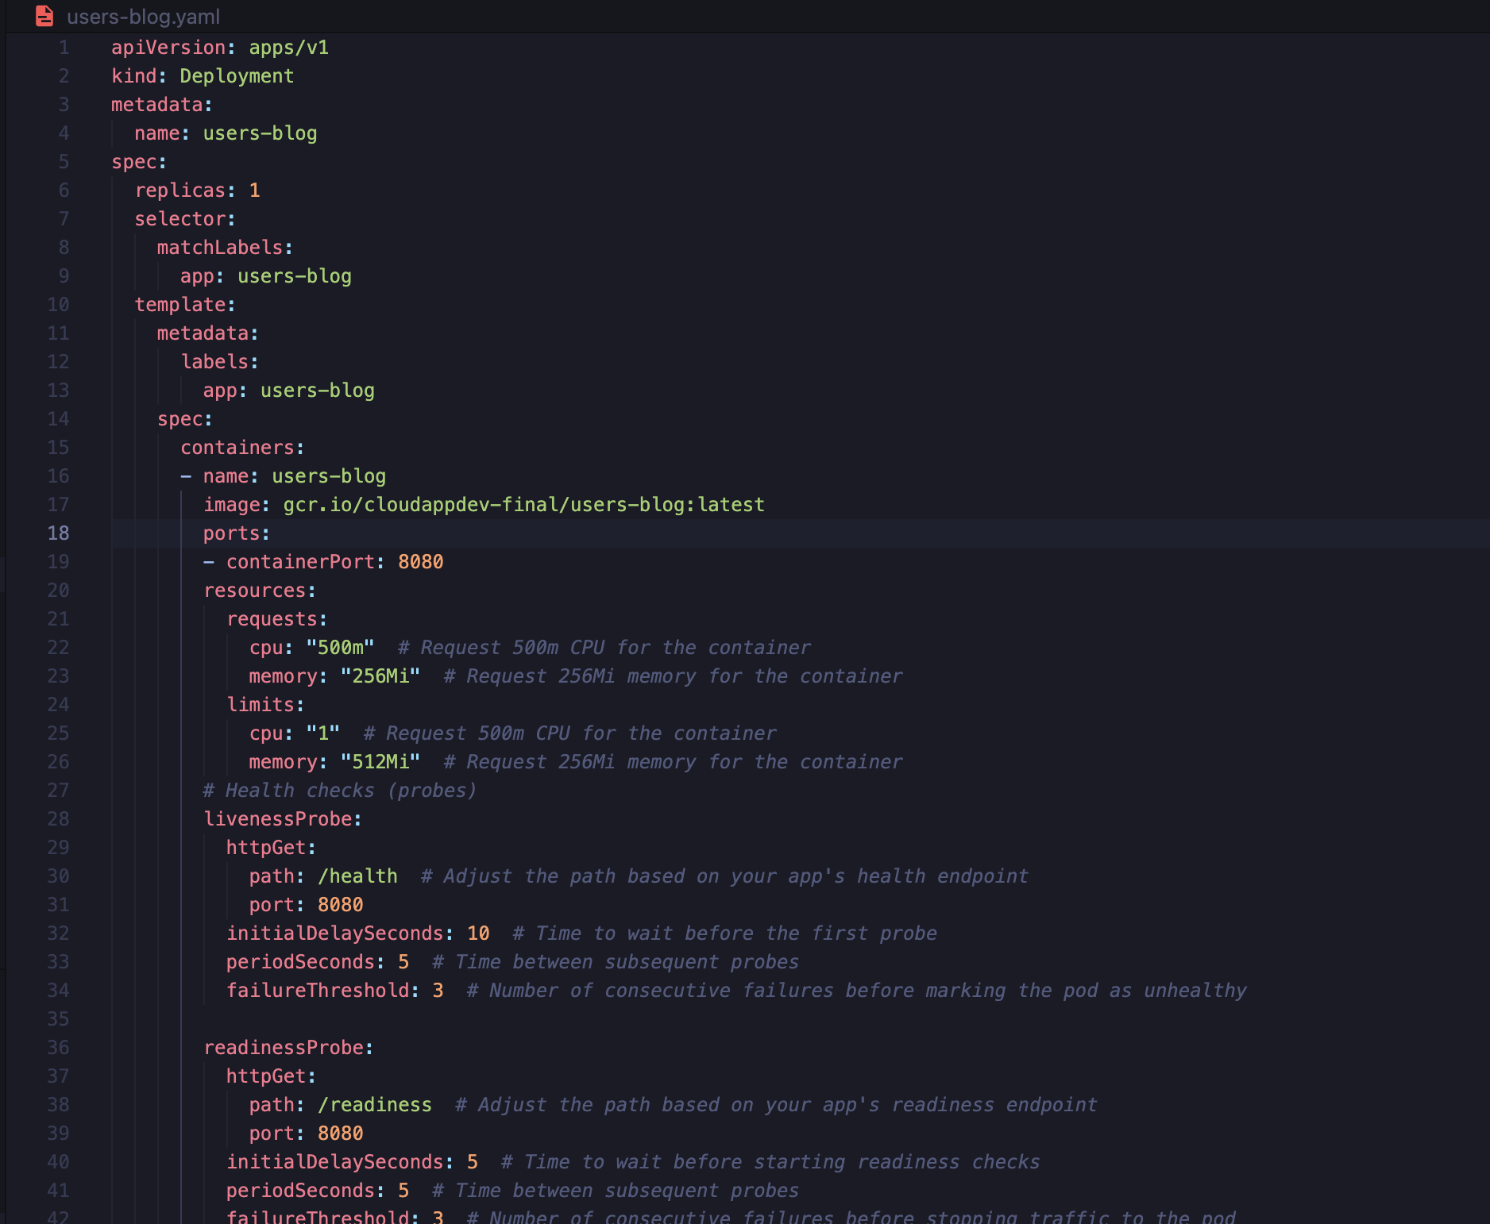

## **Performance Monitoring**

### Out of the box tool

GKE automatically enable Google Cloud Monirong tool for my cluster that monitor CPU and memory usage:  
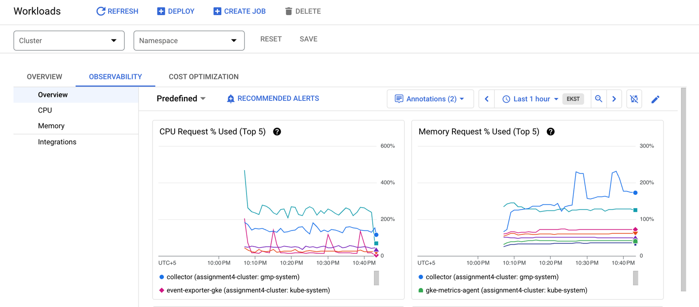

It can be found in workloads tab, observability option.

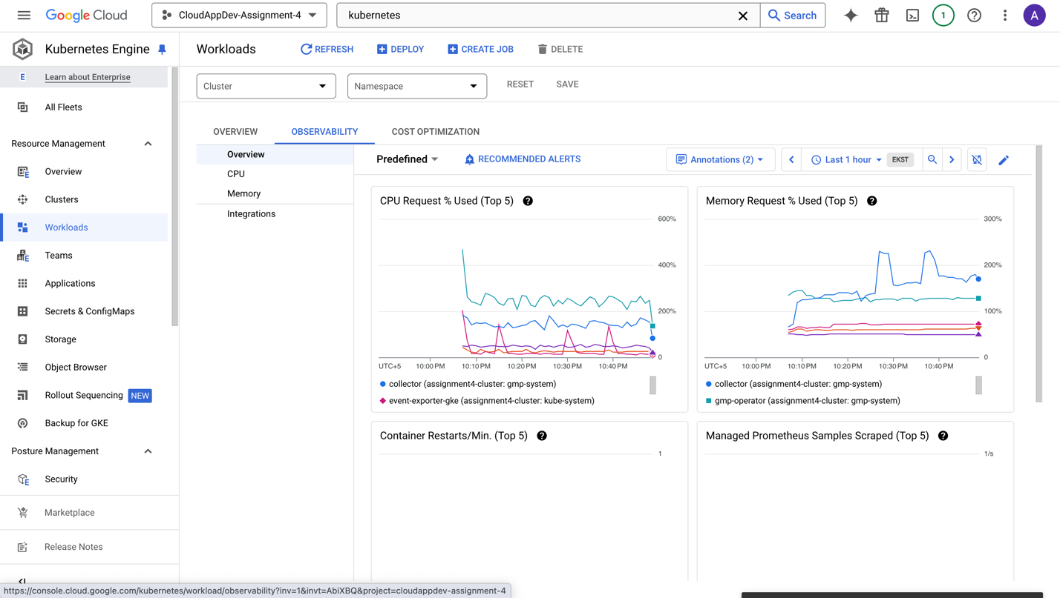

# **11. Challenges and Solutions**

During this project, I faced some challenges. First, setting up Firebase tools was hard because there were many steps, but I followed the official documentation carefully to solve it. Second, I had problems with scaling the application, so I used Kubernetes auto-scaling to handle traffic better. Another challenge was securing user data, but I fixed it by using Firebase Authentication and Cloud Functions for validation. Finally, learning how to use Pub/Sub for notifications was new for me, but with practice and examples, I made it work.

# **12. Conclusion**

# In conclusion, this project showed how to build a cloud-based event management system using Google Cloud Platform. The main findings include using tools like Firestore, Firebase, and Kubernetes to make the system secure, scalable, and easy to use. I learned how to set up auto-scaling, use Cloud Functions for security, and handle real-time notifications with Pub/Sub. In the future, I can improve the system by adding Machine Learning to recommend posts to users based on their interests.

# **13. References**

1. Google Cloud SDK - https://cloud.google.com/sdk/docs/install
2. Google Compute Engine - https://cloud.google.com/products/compute?hl=ru
3. Cloud Run functions - https://cloud.google.com/functions?hl=ru
4. Docker Documentation - https://www.docker.com/
5. Google Kubernetes Engine (GKE) - https://cloud.google.com/kubernetes-engine/docs/concepts/kubernetes-engine-overview
6. Cloud Endpoints -https://cloud.google.com/endpoints/docs/openapi/get-started-app-engine
7. API keys - <https://cloud.google.com/docs/authentication/api-keys>
8. Google Pub/Sub - https://cloud.google.com/pubsub/docs/

# **14. Appendices**

Project Structure:

